Practical Project: Guess A Number
This is additional practical project and it is not mandatory and it is not included in the final score. The main purpose is to use gained knowledge in different type of problems and to improve your portfolio and GitHub skills.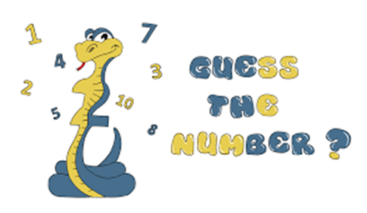
Today we will make the console game "Guess A Number". "Guess A Number" is a game in which your opponent, "the computer" chooses a random number between "1 and 100" and your task is to guess this number. After each number you enter, the computer will give you a hint of whether the number is greater or less than the number you selected until you guess the correct number:
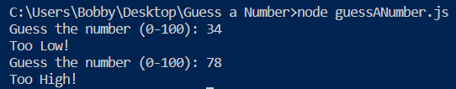
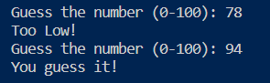

Create GitHub Repository
We already have a GitHub account created, so we're moving directly to creating a new repository.
Create a new repository from: https://github.com/new. Choose a meaningful name, e. g. "GuessANumberByUsername" add a short description and make your repo public:
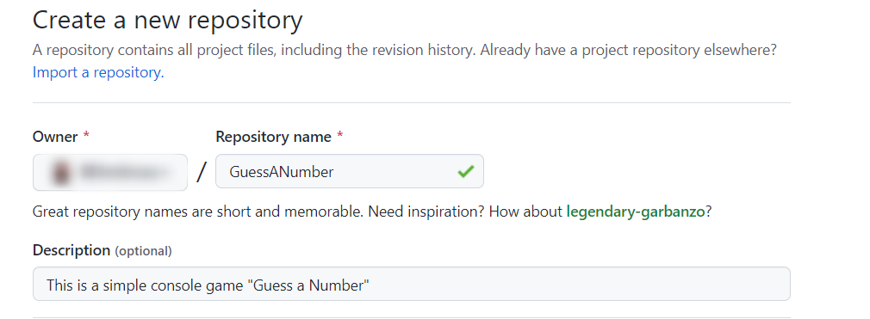
 | Please choose your original and unique name for your project!  Your GitHub profile should be unique, not the same as your classmates.  You can follow this tutorial, but you can also make changes and implement your project differ from your classmates.
Also, add a README.md file and .gitignore for Visual Studio. In Git projects, the .gitignore file specifies which files from your repo are not part of the source code and should be ignored (not uploaded in the GitHub repo). Typically in GitHub, we upload in the repo only the source code, and we don’t upload the compiled binaries and temp files.
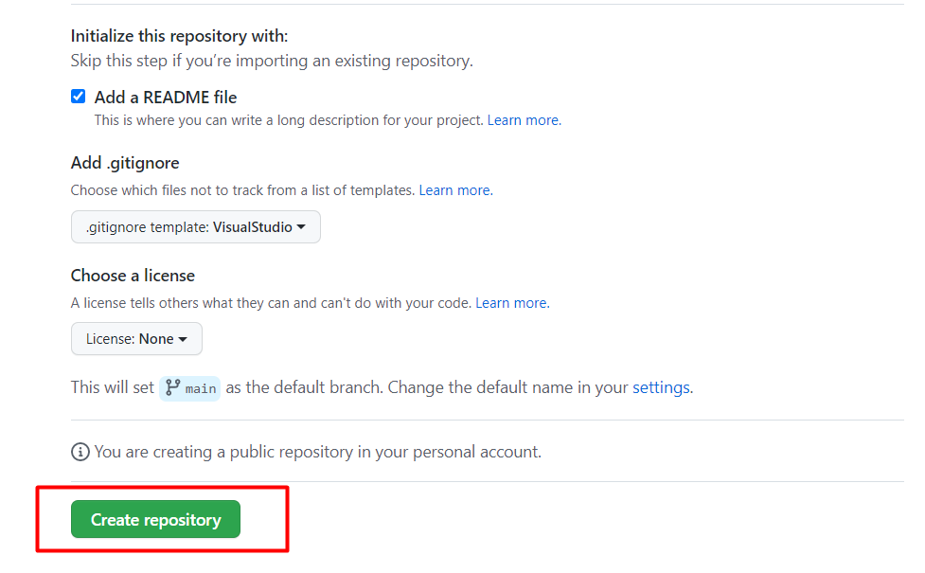
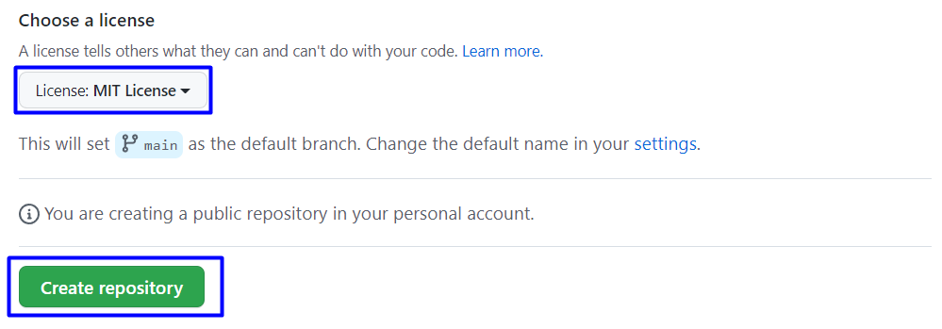
Now your repository is created and looks like this:
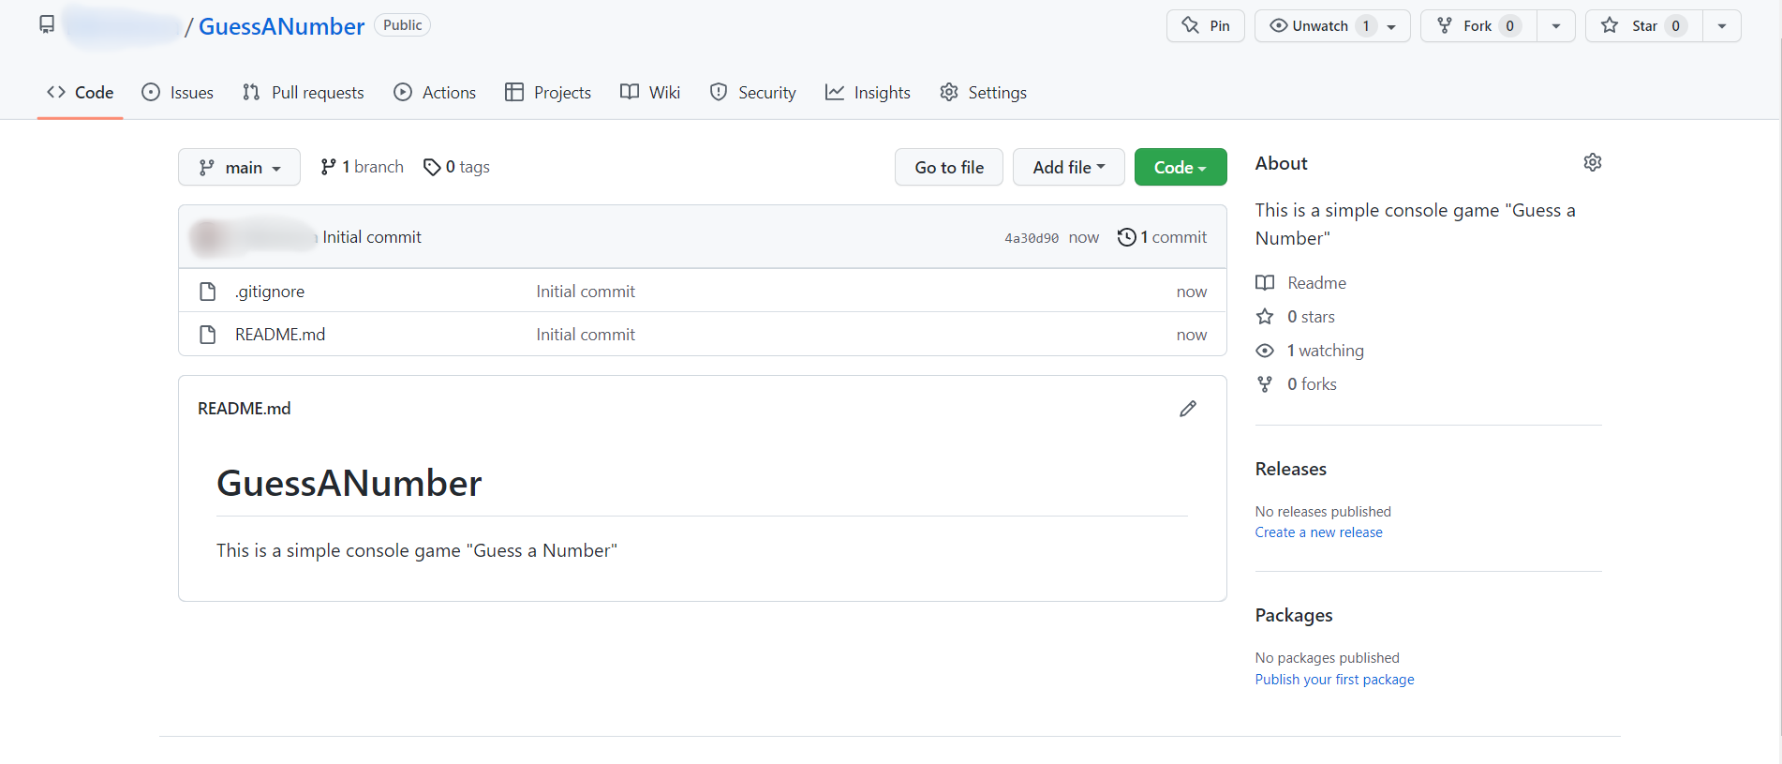
Now let's see how to write the code of our game.

Write the Game's Code
Let’s create the game and play with it.

Create a Visual Studio Code Project
First, we should start Visual Studio Code and create a new JS file. Then, choose an appropriate name and a place to save the project.

Implement the Game Logic
Now let's start working on our project.

Read Player's Move
First, we should create an interface where we can enter the number without stopping the program:
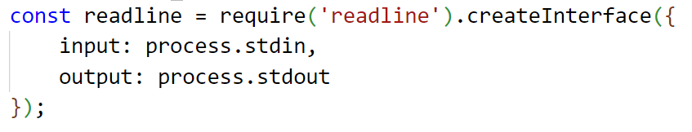
A little more information about how to create an interface: https://nodejs.org/api/readline.html
Create the already known method random, which will help us choose a random number. We will use this method so the computer can every time choose a number between "1 and 100".
You can learn a little more about it here:
https://developer.mozilla.org/en-US/docs/Web/JavaScript/Reference/Global_Objects/Math/random
Now create a function that stores the question about the number.
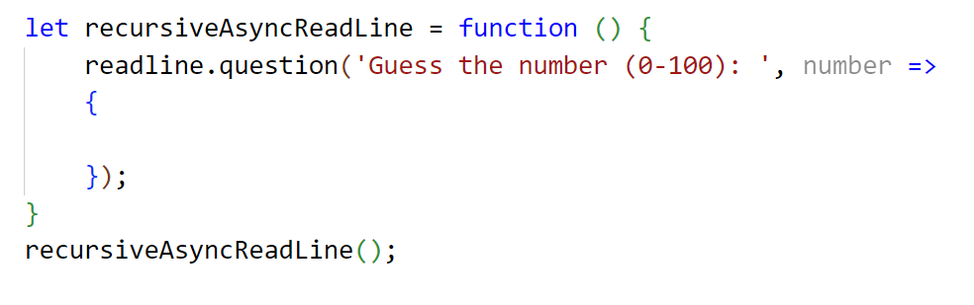
More about this readline.question you can learn: https://nodejs.org/api/readline.html
Now let's run the app in the console and check whether our current code works properly. Write in the terminal node {your file's name}.js :
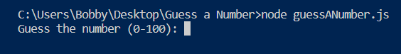

Check the Player’s Input
Now check the player's input using Number(…). If it's a number (what we expect), the methods will return a number, otherwise, "NaN".
Now we have to create our if-else statements. First, we should check if the player's input data is valid:
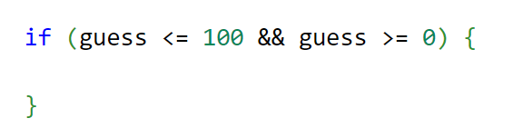
If data is valid, write a nested if-else statement in which we will check all three possible cases.
First, if the player’s number is equal to the computer’s number, that means the player guessed the computer’s number, so you should write a message and stop the application by using readline.close(). Do it like this:
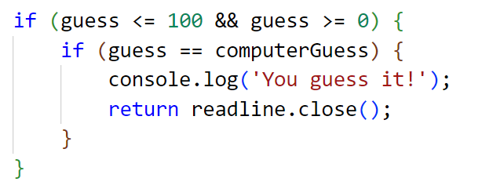
The other two cases are if the player's number is higher than the computer's number and the player's number is less than the computer's number. Write the rest of the else if statement by yourself: 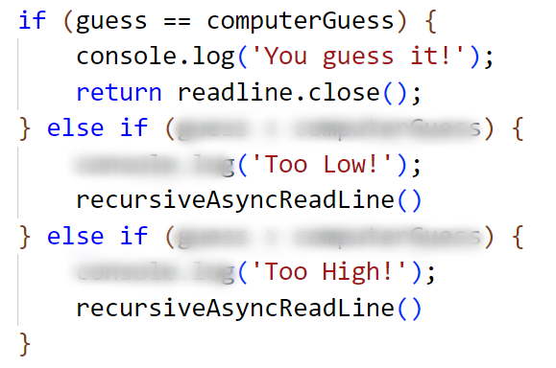
To create a repeating question after each entered number, we have to call the same function after every single answer that is not the guess number.
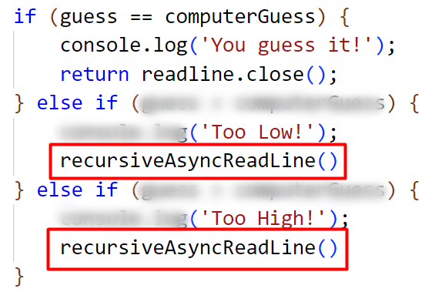
Recursion is a process of calling itself. A function that calls itself is called a recursive function. A recursive function must have a condition to stop calling itself. Otherwise, the function is called indefinitely.
Once the condition is met, the function stops calling itself. This is called a base condition. To prevent infinite recursion, you can use if...else statement (or similar approach) where one branch makes the recursive call, and the other doesn't.
More about recursion you can learn: https://www.javascripttutorial.net/javascript-recursive-function/

Now let's run the app in the console and check whether our current code works correctly:
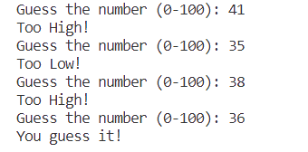
We can see that our application work's appropriately, but we are not finished yet.

Check for Invalid Input
Now what is left is to write else statement for the final case where the player’s input is invalid. That's all it takes for the game to work.
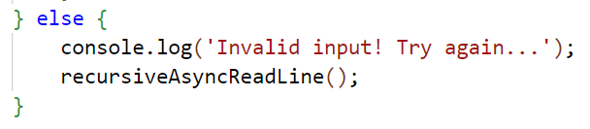
Your entire code should be similar to the following:
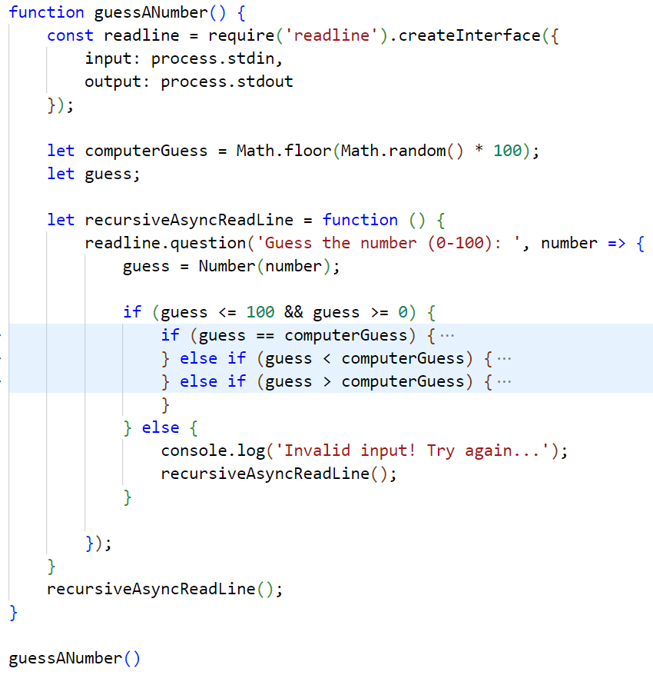

Test the Application
After you run it, the game should look like this:
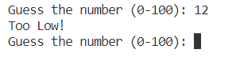
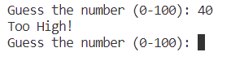
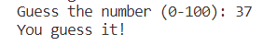
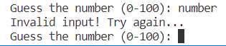

Upload Your Project to Github
We already know how to clone our repository using Git Bash or GitHub Desktop.

Use GitBash (Option 1)
Go to the desired directory, right-click on a blank space anywhere in the folder, and select "Git Bash Here" to open the Git command line console. If the "Git Bash Here" menu is missing, you should first install Git.
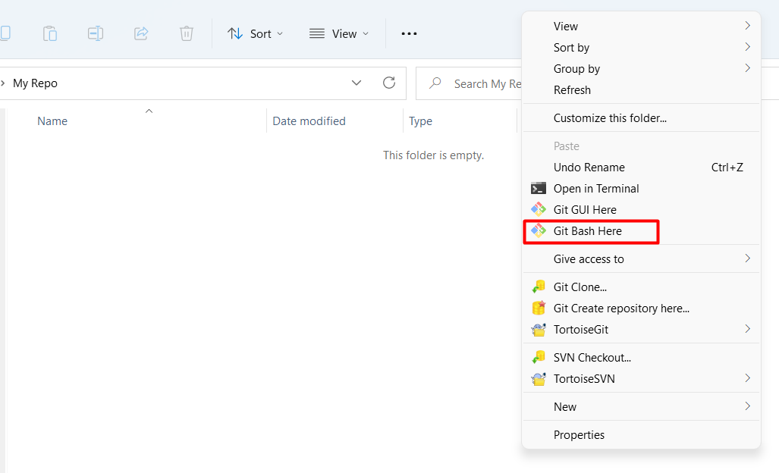
Type the "git clone" command followed by the link to your repository:
git clone
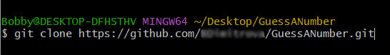
The result should be something like this:
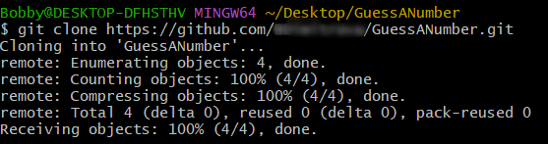
Your files from your GitHub repo will be downloaded to a sub-folder called your project in GitHub, "GuessANumber" in our case.
When we open the cloned repository sub-folder, it should look like this:
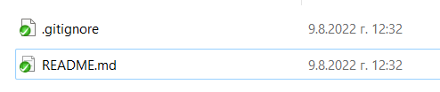
The next thing to do is to add your project files to your cloned repository folder. It should look like this:
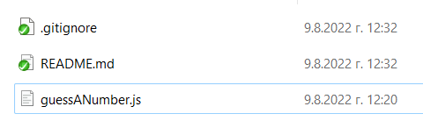
Now we are ready to upload our changes from the "Git Bash clone". Go to the desired folder, right-click on a blank space anywhere in the folder, select "Git Bash Here" and run the following commands.
Type the following command:
git status
The git status command displays the state of the working directory and the staging area.
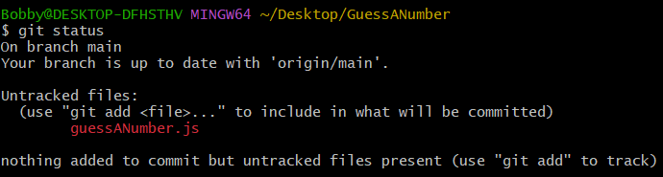
Now type:
git add .
This command adds all modified files.
Next type:
git commit -m "Your message here."
This command commits your changes. We also should add an appropriate message.
Second to the last type.
git pull
This command updates your local repository.
Now the last thing that we should do is to push our changes by using the command:
git push
This command pushes your changes to our local repository.
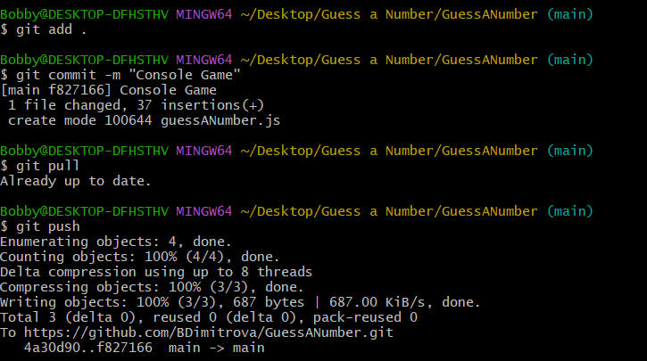
This is all you need to update your repository with Git Bash.
A little more information about it is here: https://git-scm.com/about.

Use GitHub Desktop (Option 2)
If you don't have GitHub Desktop on your computer, download and install it from here: https://desktop.github.com/
Go to "File" and choose "Clone repository".
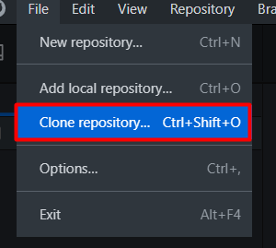
Chose the repository for the project, in our case, "GuessANumber" and hit the "Clone" button.
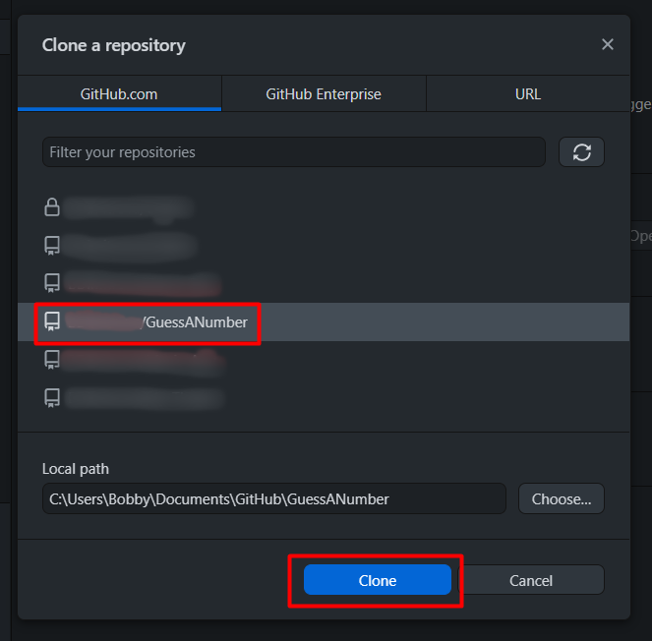
Your files from your GitHub repo will be downloaded to a sub-folder called your project in GitHub, "GuessANumber" in our case.
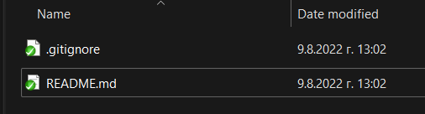
The next thing to do is to add your project files to your cloned repository folder. It should look like this:
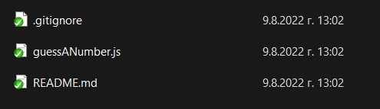
Afterward, go to GitHub Desktop and create a commit, just like this.
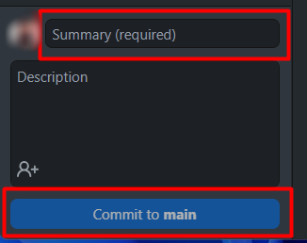
Then push the commit to the repository.
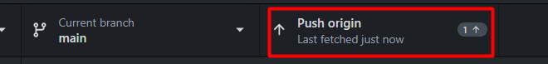
This is all you need to update your repository using GitHub Desktop.

* Modify the Code, Write Your Features
Now, it's time to play with the code and modify it.
 | This is your project. Be unique. Don't be a copy/paster!  - Implement your features.  - Implement the code yourself, using your coding style, code formatting, comments, etc.  - Make the project more interesting. Learn by playing with the code and adding your changes.
Below are a few ideas of what you can implement or modify as an addition to your code.

Add Difficulty
You can add logic for difficulty, so the player can have only a few tries to guess the number.

Restart the Game
You can automatically restart the game after it is finished (or ask the player to play again).

Additional Ideas
- You can add levels so whenever the player guesses the number, the range between the minimum and maximum number gets bigger, e. g. Level 1 (1 - 100), Level 2 (1-200), etc.
- Can you add anything else to your code based on your ideas?

Commit to GitHub
Now commit and push your code changes to your GitHub repo!
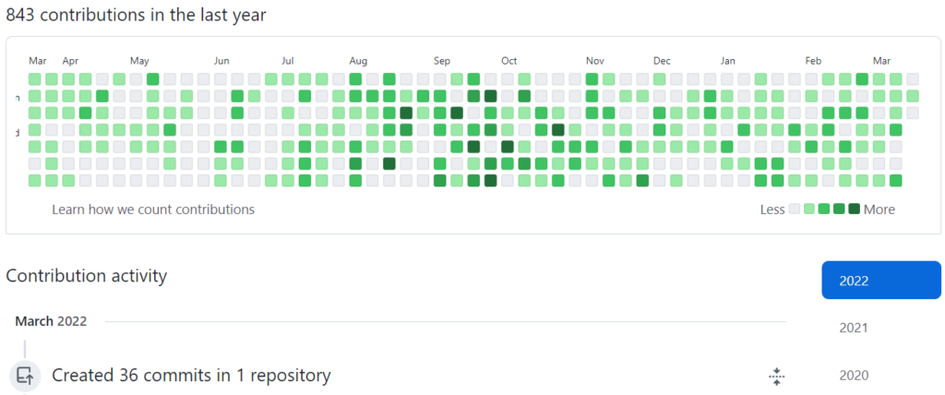 | It is very important to commit your code frequently to GitHub. This way, you create a rich commit history for your project, and your GitHub contribution graph is growing:

Create a README.md File
It's highly recommended to provide documentation as part of your project on GitHub to describe what the project is doing. So, let's make one for this project. Let's start by editing the README.md file from our repo on GitHub:
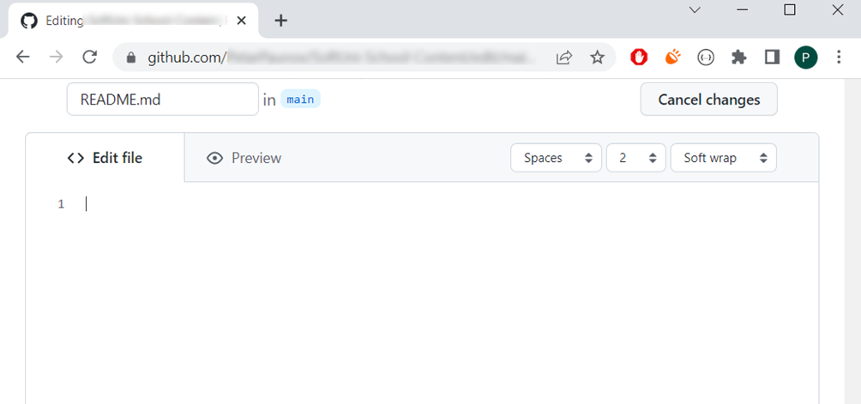
Add a project name. Use "#" in front of the text to indicate the title: 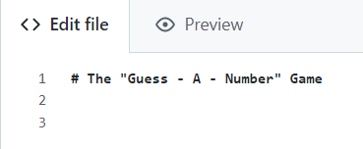
You can view the current progress by pressing the [Preview] button:

Documentation Sections
Add information about your project in your README.md file: project goals, technologies used, screenshots, live demo, etc. Typically, you should have the following sections:
- Project title (should answer the question "What's inside this project)
- Project goals (what problem we solve, e. g., we implement a certain game)
- Solution (should describe how we solve the problem algorithms, technologies, libraries, frameworks, tools, etc.)
- Source code link (give a direct link to your source code)
- Screenshots (add screenshots from your project in different scenarios of its usage)
- Live demo (add a one-click live demo of your code)

Use Markdown
Note that the GitHub README.md file is written in the Markdown language. Markdown combines text and special formatting tags to describe formatted text documents.
You can learn more about Markdown here: https://docs.github.com/en/get-started/writing-on-github/getting-started-with-writing-and-formatting-on-github/basic-writing-and-formatting-syntax.

Project Goals
Start your documentation by describing your project goals. What problem does your project solve?

Sample Documentation
This is an example of how you can document your project. Don't copy-paste it! 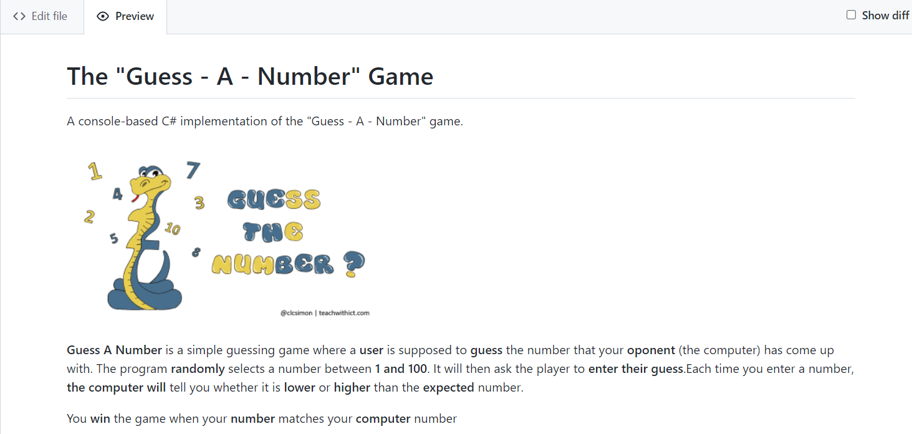
 | Write the project documentation yourself. Don't copy/paste it!  This is your unique GitHub profile and your unique project. Be different from others.
Find an appropriate image and add it. You can add images as follows:
You can add information about the inputs and outputs of the project:
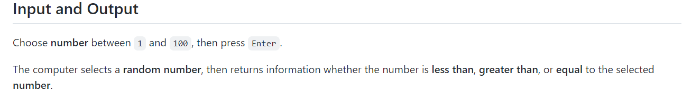

Your Solution
Describe how you solve the problem: algorithms, technologies, libraries, frameworks, tools, etc.

Link to the Source Code
[Source Code](guess_a_number.py)

Screenshots
Add screenshots of your project:
- Take a screenshot with your favorite tool (e.g., the Snipping Tool in Windows).
- Paste the screenshot in the GitHub Markdown editor using [Ctrl+V]:
Example screenshots for the "Guess a Number" game:
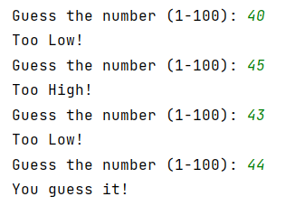
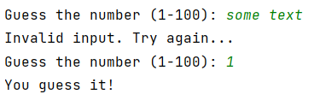

Upload Your App to Replit
You already should have a Replit profile. Now let's add our project there so we can share it with our friends and add it to our GitHub profile. You already should know how to do that.
Open the menu in the upper left corner. Click "Create", then select the language in which your project is written, select a name, and create the project Node.js
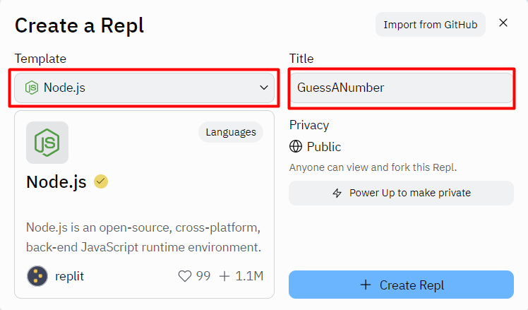
Paste your code in the "guessANumber.js" file:
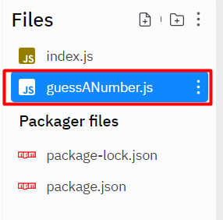
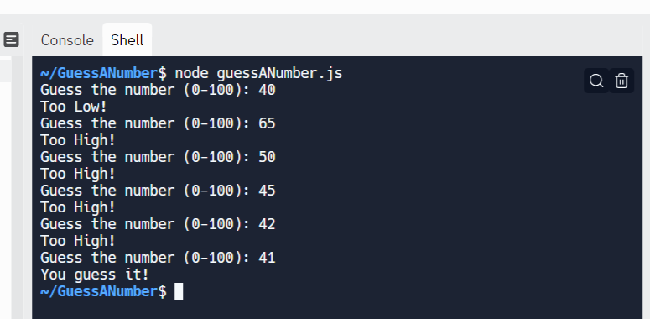
You can now share your app with your friends.

Add Replit Link to Your README.md
Now add a "one-click live demo" of your project from your GitHub project documentation. You can do it as follows:
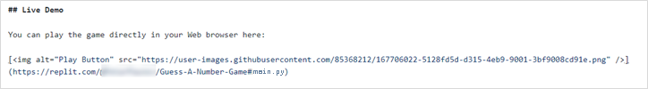
You can take a screenshot from Replit.com and paste it into the GitHub documentation editor directly with [Ctrl+V].
Now we have completed our second console game, and we have our second project in our GitHub portfolio.

